Article

AUMOR-AR: Mobile Application for University Orientation Delivering Information at Point of Need

Muhammad Nadeem 1,*, Firstname Lastname 2 and Firstname Lastname 2,*

|  |
| --- |
| Academic Editor: Firstname Lastname  Received: date  Revised: date  Accepted: date  Published: date  **Citation:** To be added by editorial staff during production.  **Copyright:** © 2025 by the authors. Submitted for possible open access publication under the terms and conditions of the Creative Commons Attribution (CC BY) license (https://creativecommons.org/licenses/by/4.0/). |

1 College of Engineering and Technology, American University of the Middle East, Egaila 54200, Kuwait

2 **\***Correspondence: Muhammad.nadeem@aum.edu.kw

**Abstract:** Freshmen students are often required to absorb a large amount of new information within a short period of time, which can be both academically and emotionally challenging. In response to this challenge, this study introduces AUMOR-AR, a mobile application designed to enhance university orientation by delivering contextual information at the point of need. The application integrates GPS-based localization with QR code triggers to provide real-time, location-specific guidance and interactive content through an augmented reality (AR) interface. It uses GPS functionality to provide real-time location-based services including information about academic buildings, student services, and recreational facilities. Scanning QR code placed on certain devices and lab equipment allows users to access relevant information. This study presents the development process of AUMOR-AR, including its conceptual framework, design considerations, and implementation plans. The research follows a user-centered design methodology, incorporating with new students to evaluate usability, accuracy, and engagement. Results demonstrate that AUMOR-AR significantly improves spatial awareness, reduces confusion during orientation, and enhances user satisfaction compared to traditional printed or static digital maps. The system offers a scalable solution for smart campus environments and contributes to the broader field of context-aware mobile learning and AR-assisted navigation.

**Keywords:** Augmented Reality (AR), Mobile application, University orientation, GPS Navigation, QR Codes, Technology acceptance model (TAM), Context appropriate information

1. **Introduction**

Every year, hundreds of thousands of students leave college and enter universities to become successful professionals. As institutions of higher learning, universities are crucial for helping students develop their intellectual capacity and prepare for workforce demands (Attereya, 2021). University orientation programs serve as critical transitional experiences for new students entering higher-education institutions. Students who participated in this program often performed better academically than those who did not attend the orientation program. Due to reasons the orientation of campus including labs is a crucial part of new student onboarding and improves their chances of success. Before being permitted to work in the lab, students at many universities must also undergo the lab orientation program. Orientation not only motivates students but also helps them build solid social networks and adjust to the academic environment more effectively (Mohazana, xxxx).

Although valuable, traditional orientation methods may not always adequately address the diverse needs and preferences of modern learners and may be expensive. For example, orientation fees in the U.S. range from $100 to over $500 per student, with UNC-Chapel Hill charged $232, Stanford $525, and Canadian universities average C$90 (~US$63), funded through student fees and university support. Australia uses the Student Services Fee for free "O-Week" events (Education Department Australia). European orientations are typically free and funded by universities and student unions in the EU. Orientation is a valuable investment in students’ success.

In recent years, advancements in mobile technology have opened new avenues for enhancing the orientation process of new employees. Mobile applications have emerged as powerful tools for delivering personalized and interactive experiences to higher education students. By leveraging features such as GPS navigation and QR code scanning, mobile applications can revolutionize students’ engagement with university environments. The integration of augmented reality (AR) technology further extends the capabilities of mobile applications by offering immersive and interactive experiences that blend digital content with the physical world. By overlaying virtual information in real-world environments, AR applications can provide students with contextualized guidance, information, and engagement opportunities during university orientation. In 2024, the global augmented reality market was valued at USD 83.65 billion, and between 2025 and 2030, it is projected to expand at a compound annual growth rate (CAGR) of 37.9%.

Furthermore, campus life often feels like a survival challenge: students race between buildings, get lost indoors, and juggle multiple apps that do not show what is inside a building or how to reach services on time. The result is not just tardiness; it is a steady drain on energy, productivity, mental clarity and confidence. This is less a time-management issue than a design problem, revealing the need for a smarter, student-centric tool to assist teachers in their work. This problem can be addressed through a personalized campus companion for students which helps finding and information about the nearby labs and equipment inside it, classrooms, study zones, cafés, and library rooms thus making daily academic life faster, smarter, and calmer, avoiding the chaotic, inefficient days that occur without it.

University orientation programs often face challenges in effectively assisting new students in navigating campus facilities, accessing relevant information, and fostering a sense of belonging among them. Traditional methods may not fully accommodate to the diverse requirements and preferences of modern students, leading to inefficiencies and gaps in the orientation process. This research was motivated by the recognition of the challenges faced by new students during the orientation process and the potential of mobile-AR technology (MAR) based application tailored specifically for university orientation. We propose AUMOR-AR (American University of the Middle East Orientation using Augmented Reality) That will provide incoming students with a seamless and intuitive tool for navigating the campus, accessing relevant information, and fostering a sense of connection with their academic community. The objectives of this study were as follows.

* Design and implementation of a mobile application integrating GPS navigation, QR code scanning, and AR features to facilitate university orientation for incoming students.
* Curating and organizing information about the buildings as well as lab equipment within the mobile application for easy access and retrieval by students.
* Conducting usability testing and user feedback sessions to assess the ease of use, functionality, and user experience of AUMOR-AR.
* Measuring the effectiveness of the application in supporting students' orientation experience, including their ability to navigate campuses and access to information.

Using Mobile applications students can easily access information anytime and anywhere using their smartphones or tablets. This level of accessibility enables flexible learning opportunities and accommodates the diverse schedules and preferences of students. The GPS and QR code functionalities empower students to have convenient on-demand access to relevant information and resources, thereby facilitating a smoother transition into university life. This creates immersive and interactive experiences that engage new students in their campus environment, fostering a sense of connection and belonging to the university. This study also provides valuable insights and practical solutions for enhancing university orientation practices through the development and assessment of an AR mobile application.

1. **Literature Review**

University often conducts orientation programs before the start of the academic term that are designed to provide incoming studentss with essential information, resources, and support to help them acclimatize to campus life and succeed in their academic endeavors. They introduce the university's policies, procedures, and academic requirements and may include presentations, campus tours, information sessions, and campus events and activities. These sessions aim to address the common questions and concerns of new students regarding the program and provide opportunities to connect with their peers, build relationships, and engage in campus life. Many universities also offer online orientation resources, such as webinars, videos, and interactive modules, to supplement in-person orientation sessions. These resources allow students to access information at their own pace and schedules.

* 1. *Role of Mobile Applications in Education*

Mobile applications have drastically changed educational methods as well as the ways of students’ access, engagement with educational contents. The pervasive use of smartphones have learning experiences that go beyond the limitations of traditional classrooms through flexibility, interactivity, and personalization (Chandran et al., 2022; Naveed et al., 2023). This rising interest in the field has stimulated researchers to engage more in exploring it further. According to a recent systematic review of Scopus-indexed literature, a substantial increase in mobile learning research has been noted between 2018 and 2022 (Mercan et al., 2024). The popularity of mobile devices stems from the accessibility offered enabling students to engage with educational content anytime and anywhere, successfully averting both geographical and temporal barriers to learning which is very crucial in university settings where students often have to balance multiple responsibilities (Naveed et al., 2023). They provide an easy access to resources including texts, instructional videos, discussions, and assignments significantly enhancing student engagement and motivation (Briz-Ponce et al., 2017). Moreover, availability of the interactive and personalized multimedia features caters to the diverse learning styles resulting in deeper cognitive engagement in the learning process. The most commonly integrated tools include quizzes, simulations, and learning pathways that dynamically adjust to individual student progress and performance supporting innovative instructional methods, such as microlearning (Samala et al., 2023). It helps with providing immediate feedback, enabling self-regulated learning and allowing students to identify and address areas that need improvement. Through a meta-analysis of 15 studies with 962 participants Chandran et al. (2022) demonstrated that the use of mobile application considerably improves academic performance of students when compared to traditional methods. Furthermore, applications enhance collaborative and communicative practices in educational settings by effectively bridging the psychological and pedagogical gaps between learners and instructors (Park, 2011). Mobile computer-supported collaborative learning (mCSCL) has been reported to improve collaborative as well as critical 21st-century skills invaluable for future academic and career success (Sung et al., 2017). Beyond instructional applications, mobile apps have significantly streamlined administrative and support functions in educational institutions. Universities use dedicated apps for operational aspect of academia thereby enhancing overall operational efficiency (Chandran et al., 2022, Nadeem). The introduction of mobile-based assessment and feedback has made it possible for educators to have a real-time insight into students’ progress. Also, the analysis of huge amount of digital data makes it possible to monitor the student engagement and develop adaptive instructional strategies (Naveed et al., 2023). To cut short, mobile applications have become integral part of the current educational ecosystems, substantially improving educational outcomes.

* 1. *GPS and QR Code Technologies in Navigation Apps*

The integration of Global Positioning System (GPS) and Quick Response (QR) code technologies in these apps has significantly enhanced their functionality, accessibility, and usability. The GPS system, or global positioning satellite system, was created in the United States. The atomic clock is in sync with all 24 of the satellites orbiting the earth. Each satellite continuously broadcasts its position coordinate and the precise time of its placement. Every GPS portable device uses location data from at least four satellites to establish its position. After that, the gadget determines a position fix at its present location. GPS technology has revolutionized navigation by enabling real-time tracking of user locations using satellite signals, allowing navigation applications to provide turn-by-turn directions, route optimization, and location-based services Cahn and Markert (2017). The integration of GPS in smartphones has led to the widespread adoption of navigation apps such as Google Maps offer seamless navigation experiences. GPS coordinates can be enriched with contextual information such as time spent and activities at a particular location to provide more meaningful insights (Bhadane). The performance parameters such as accuracy and reliability of GPS in navigation apps are of utmost important particularly in urban environments with high-rise buildings and signal interference Huang et al. (2019). One of the major challenges faced by GPS technology is the signal loss in dense urban areas or indoor environments. This has stimulated the researchers to explore alternative positioning methods and hybrid solutions to improve navigation accuracy (Li et al., 2018).

A QR code is an image that encodes distinct data dots and black squares which can be instantly deciphered by utilizing the camera on a smartphone, transforming the data into a format that is readable by humans. QR codes streamline the delivery process by providing quick access to essential information, reducing the time needed for manual data entry and verification (Regla) QR codes are used to manage medical (Chu) and industry (OGAR) equipment repairs and maintenance. Engineers can quickly access detailed equipment information via QR codes, significantly improving repair efficiency and reducing downtime. The rapid adoption of QR codes has raised security issues, particularly when used with smart devices. Ensuring secure scanning and data protection is crucial to prevent misuse and hacking.

The incorporation of GPS and QR code technologies into a single system may offer benefits of real-time location tracking with information retrieval. Chen et al. (2020), QR codes supplement navigation by providing users with additional context, directions, and points of interest along their route. Such enhancement not only provides rich experience but also increases user engagement. Recent advancements in AR technology have made it possible to integrate GPS and QR codes into navigation applications by overlaying digital information, such as route directions, points of interest, and location-based alerts, onto a user's real-world environment in real time. This immersive approach enhances situational awareness and facilitates intuitive navigation experience (Kushleyev et al. 2021).

* 1. *Previous Studies on Mobile Apps for University Orientation*

Many universities have adopted MAR as an innovative approach for students to explore the campus independently. This not only reduces the need for staff involvement but also saves time and resources that are typically required for guided tours. Use of AR in university orientation offers numerous benefits, such as enhancing student engagement and providing immersive experiences for students. It provides an interactive way for students to familiarize themselves with campus environments, degree programs and course curricula reducing students' fear of failure or withdrawal by making them more comfortable with their new learning environment (Ngyuen). The development of AR technology for campus orientation and tours was first introduced by Columbia University, which employed head-mounted displays along with GPS and orientation tracking to present campus visitors with tour information in the form of three-dimensional (3D) graphics (Feiner et al., 1997). Fu-Jen Catholic University was one of the pioneers in utilizing AR, specifically to help new students become familiar with the campus layout (Chou & ChanLin, 2012). Similar initiatives were launched at Lehigh University and Columbia University, where AR apps were developed to help users identify buildings (D. Lial. (l., 20) provided comprehensive campus tours (Low & Lee, 2vely. Finally, Mobile AR has been utilized at the Autonomous University of Nayarit to create an autonomous learning process that helps users discover campus locations. This system provides information about degree programs, curricula, and the main buildings on campuss (Iriarte-Solis et al., 2016). Some of these applications even offer features such as indoor location detection and tracking (Hamza-Lup et al., 2018). The Bowling Green State University used AR-based mobile apps for helping visitors in exploring campus cultural activities or events and guide them to specific locations (Chao et al., 2014; Wong, 2013).

Som researchers used different multimedia contents and features to enhance the effectiveness of the applications. Researcher ay Yu et al. at Chung Hua University used audio and visual elements to provide information on the campus’s ecological environment creating an environmentally friendly navigation system (M. Li et al., 2021; Yu et al., 2015). Some researchers used voice-command search for locating and sharing places (Al Delail et al., 2012). Similarly, researchers at University of Quindio introduced a 3D directional board in their app that led visitors to various campus locations (Giraldo et al., 2016). At Mil. Nueva Granada University, Garay-Cortés, and Uribe-Quevedo integrated landmarks on campus that trigger mini-games through location services and dynamic maps for guiding new students (Garay-Cortes & Uribe-Quevedo, 2016). Other used image of the location taken through camera which are processed to detect places and display relevant details on the screen (Özcan et al., 2017). Nguyen et al. designed an AR application to assist students who missed orientation week at Haaga-Helia University of Applied Science, allowing them to catch up on essential information (Nguyen et al., 2018). Andri developed AR and virtual tour applications for students of the Management and Science University, that allows users access hidden details such as building descriptions, staff information, and cafeteria menus by pointing their smartphones at signboards. It also provides a virtual 360-degree panoramic view of the campus buildings and facilities for student working remotely (Andri et al., 2019).

AR applications can help in improving student engagement and motivation as demonstrated by (Nadeem) who designed an AR-based lab orientation application and demonstrated that it was more engaging and supportive than traditional methods, helping students better understand laboratory equipment and safety rules (Nadeem). AR can improve spatial orientation skills, which are crucial for navigating new campus environments and improved their spatial orientation skills of students using such app compared to those who did not (Carrera). Durham University uses the campus's WIFI network to triangulate users' positions using a mobile client on a WIFI-enabled phone or PDA with an aim to provide them with information required at the point of need as and when needed (Batty and Kyaw, 2009). The University of Huddersfield used QR codes to deliver context appropriate help and information at the point of need (Walsh 2010).

The integration of GPS and QR code technologies into navigation applications enhance navigation efficiency, reduce cognitive load, and improve overall user satisfaction by providing accurate location information, contextualized guidance, and on-demand access to relevant information (Wu et al., 2018). The integration of these technologies into AUMOR-AR benefits by combining real-time location tracking with on-demand information retrieval to provide users with seamless navigation experience. The hot loading feature of this does not require any recompilation and contents can be updated at any time making this app useful for the students throughout their stay at the University due to its ability to deliver information at the point of need.

* 1. *Theoretical Framework*
     1. *Conceptual Basis of AUMOR-AR*

This application integrates GPS, QR codes, and AR technologies to provide users with a seamless and enriched experience. GPS provide location-aware information during the navigation. QR codes serve as digital markers and can quickly retrieve specific content, such as website URLs, text, images, or multimedia upon scanning. This enables users to access relevant information and resources by simply scanning the designated QR codes placed throughout the environment. AR technology superimposes digital content, such as images, videos, or 3D models, onto a real-world environment, creating an augmented view of reality. By overlaying virtual informationn onto physical spaces, AR enhances users' perceptions of their surroundings and enables an interactive experience. In the context of application, AR can be utilized to provide users with contextualized information that enhances engagement and immersion within the environment. Together, these technologies create a powerful platform for delivering personalized, context-aware experiences that cater to the diverse needs and preferences of users during university orientation and thereafter.

* + 1. *Theoretical Perspectives on Mobile Learning and Navigation*

AUMOR-AR encompasses several key theoretical perspectives that inform its design, development, and implementation. First, the Situated Learning Theory emphasizes the importance of context and social interactions in the learning process (Lave & Wenger, 1991). Within the context of GPS and QR code-based AR applications, Situated Learning By embedding educational content, interactive challenges, and guided exploration into the user’s surroundings, the application facilitates experiential learning and knowledge acquisition that are directly relevant to the user’s context (Dunleavy et al., 2009). The design of AUMOR-AR is also supported by information processing theory focuses on how learners acquire, process, and retain information (Atkinson & Shiffrin, 1968). By optimizing the presentation of information, providing scaffolding and guidance, and incorporating interactive elements, the application enhances users' information-processing capabilities and facilitates effective learning and decision-making (Wu et al., 2013). Drawing on principles such as simplicity, consistency, feedback, and affordance (Norman, 2013), UX design informs the development of application interfaces, navigation flow, and interaction design. By prioritizing user needs, minimizing cognitive load, and maximizing usability, the application enhances user satisfaction and engagement with the AR experience (Bacca et al., 2014). Finally, Spatial cognition and navigation theory explores how individuals perceive, interpret, and navigate spatial environments (Montello, 2005). AUMOR-AR incorporates spatially aware features, such as GPS-based navigation, AR overlays, and landmark recognition enhances their navigation efficiency and spatial understanding within the physical environment (Kljun et al., 2019).

* 1. *Technology Acceptance Model*

The adoption and use of information technologies have long been recognized as delivering both immediate and long-term benefits at the organizational and individual levels, including improved performance, efficiency, and convenience. In the 1980s, with the rise of personal computers, research on technology adoption gained prominence; however, early studies lacked empirical insights into users’ responses to system performance. Prior research emphasized user involvement in system design and the evaluation of systemm characteristicss yet relied heavily on subjective performance measures that were often unreliable and weakly correlated with actual use. To address these shortcomings, scholars have turned to the Theory of Reasoned Action (TRA) to explain the attitudinal drivers of behavior; however, its generic nature limits its application to information systems. Recognizing the need for a more tailored framework, Davis (1989) developed the Technology Acceptance Model (TAM), which is grounded in the TRA but specifically focuses on technology use and its acceptance. It provides a theoretical foundation for understanding user acceptance and technology adoption. By examining factors such as perceived usefulness, ease of use, and attitude toward technology, TAM helps predict and explain users' intentions to use GPS and QR code-based AR applications. TAM insights can inform the design of user-friendly interfaces and features that align with users' needs and preferences, thereby enhancing acceptance and adoption. It explains how individuals accept and adopt new technologies by focusing on two key factors: perceived usefulness (PU) and perceived ease of use (PEOU). PU refers to the extent to which a person believes that using a system enhances their performance, and PEOU reflects the belief that using a system requires minimal effort. These beliefs shape users’ attitudes toward using technology, which then influences their behavioral intention to use it and, ultimately, their actual system use. TAM also recognizes the role of external variables, such as system design, user characteristics, training, and support, which impact both PU and PEOU. Moreover, PEOU not only directly influences attitudes but also enhances PU, as users are more likely to find a technology useful if it is easy to use. The model is valued for its simplicity and predictive power and has become a foundational framework in information systems research, often extended with additional constructs such as social influence, enjoyment, and facilitating conditions, to better capture diverse adoption contexts.

1. **Methodology**
   1. *Research Design*

This study adopted a mixed-methods approach which is dominated by quantitative analysis. Qualitative data was collected using open-ended questions to supplement the quantitative data. This amalgam of both methods provided a comprehensive understanding of user acceptance. It not only captures measurable perceptions but also uncovers nuanced feedback that might be overlooked in structured items. This approach is particularly valuable in evaluating app as user behavior and attitudes can be influenced by a variety of contextual factors.

* 1. *Data Collection Methods*
     1. Research Subject

A total of 128 participants, including undergraduate students (aged 19–22) and faculty members from the electrical engineering department, participated in the study. All participants were engineering students (and staff), and the majority belonged to the third and fourth years of an undergraduate computer and electrical engineering program. Additionally, the participants had previously experienced augmented reality in one way or another.

* + 1. Research Sample Selection

Students taught by the researchers were invited to participate in the survey through direct invitations during lectures. Students who volunteered to participate in this study were recruited for the study. If a participant decided to withdraw after providing consent, the next participant was contacted to take their place. The participating students and facilitators belonged to the same department (EE). The survey was conducted at the AUM campus during university hours but outside the lecture hours. The participants were chosen on a first-come, first-serve basis and did not receive any rewards for their participation.

* + 1. Questionnaire

The data was collected using a structured questionnaire designed based on the TAM framework, incorporating additional elements relevant to the evaluation of AUMOR-AR. The instrument combined quantitative and qualitative items to assess user perceptions, attitudes, behavioral intentions, and experiences. It consisted of 27 items, divided into seven sections as shown in *Table 1*.

**Table 1.** Questionnaire structure and constructs

|  |  |  |  |
| --- | --- | --- | --- |
| **Section** | **Construct** | **Items** | **Type** |
| Section 1 | Participant Demographics | Q1–Q4 | Categorical/Ordinal |
| Section 2 | Perceived Usefulness (PU) | Q5–Q9 | 5-point Likert |
| Section 3 | Perceived Ease of Use (PEOU) | Q10–Q15 | 5-point Likert |
| Section 4 | Attitude Towards Use (ATU) | Q16–Q19 | 5-point Likert |
| Section 5 | Behavioural Intention to Use (BIU) | Q20–Q22 | 5-point Likert |
| Section 6 | Actual Use (AU) | Q23–Q25 | Mixed (Likert/Open) |
| Section 7 | Open-Ended Feedback | Q26–Q27 | Open-ended text |

All Likert items used a 5-point scale: 1 = Strongly Disagree to 5 = Strongly Agree

Cronbach’s alpha was used to measure internal consistency of each construct. The instrument was structured carefully so that it aligns with TAM constructs and allows us to obtain exploratory feedback through open responses at the same time. This hybrid approach provided both statistical measurability and user-centered depth which provides a robust foundation for understanding user acceptance and improving the AUMOR-AR.

* + 1. Research Procedure

If a student was willing to participate, a meeting was scheduled with the student, where only one researcher and the participant(s) were present. The researcher conducted the evaluation and explained the research and the procedure for carrying out the test to the participant(s). Respondents were briefed about the study purpose, anonymity, and consent before participation. Participants were informed that their participation is voluntarily and that they could exit the study at any time without any personal consequences. They were provided with an Android smartphone with a pre-installed orientation application (AUMOR-AR) inside the campus. The application include a video tutorial to guide students and reduce their dependence on external assistance. After using the application, the participants were asked to complete a paper-based questionnaire evaluating its performance, comfort, usefulness, and helpfulness. The data was collected over a period of one month during summer 2025.

* + 1. Apparatus

In our study, we use Android-based smartphones for evaluating the application. The model used was Samsung Galaxy S21 SM-G991B with 128 GB storage, 8 GB RAM Dynamic AMOLED 2X display running Android 14. It has Exynos 2100 Octa-Core CPU processors and ARM Mali-G78 MP14 GPU graphics card. Alternatively, students could download the application from the Play Store and install it on their phones. We used built-in technologies including GPS for location, the camera to scan barcode, and touchscreen for interaction.

* + 1. Research Ethics

This study involved human participants and required approval from the concerned authorities. The protocol was approved by the research committee at AUM (reference xxxx). The research required interactions faculty conducting the survey and the participants. Therefore, the researcher was aware of the participants’ identities, and anonymity was not possible. The questionnaire provided to the participants was anonymous and did not obtain any information that could help to identify them.

* + 1. Research Hypotheses

The following hypotheses were developed based on TAM constructs and the structure of the questionnaire:

* H1: PEOU has a positive effect on PU.
* H2: PU has a positive effect on ATU.
* H3: PEOU has a positive effect on ATU.
* H4: ATU positively influences BIU.
* H5: PU positively influences BIU.
* H6: BIU positively AU.

A graphical illustration of research hypothesis is also provided in *Figure 1*.

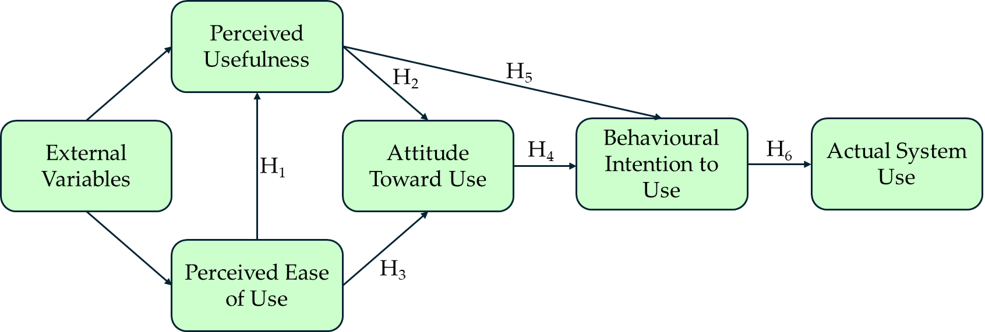

**Figure 1.** Illustration of TAM-based research hypothesis

* 1. *Implementation Plan for University Orientation*
     1. AUMOR-AR architecture

Figure 2 illustrates the architecture of AUMOR-AR. It consists of a remote data server and a wirelessly linked mobile client application that runs on the Android operating system (OS) platform, which communicates with each other using the JSON protocol. The user engages with the application by using the camera and GPS built into the device to scan the QR code and provide the user's position, respectively. Both the camera and GPS feed their data into the AR Display, which becomes the user's interaction layer with the application. The user request, which includes GPS coordinates and scanned QR information, is structured in JSON format and sent to the remote server. This ensures interoperability and lightweight data processing for the proposed system. The JSON-formatted AR content is stored on a server or repository such as GitHub. The AUMOR-AR parses the JSON format that the server provides in response to this request in real time and incorporates it into the display. The server parses the incoming request, matches the data with the appropriate AR content, and sends a JSON-formatted response containing AR assets such as text, images, or videos. The AR content can be updated dynamically on the server without the need of recompilation saving time, resources, and simplifying content maintenance for the developers and administrators.

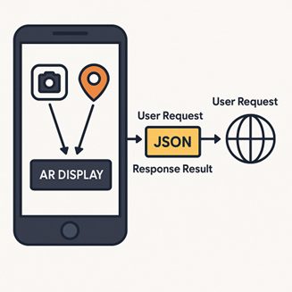

**Figure 2.** System architecture

* + 1. Development Process of AUMOR-AR

We used an incremental development model for mobile application development, as shown in Figure 3, which is an iterative approach that involves breaking down a project into smaller and manageable increments or iterations. Each iteration focuses on delivering a specific set of features or functionalities, allowing continuous improvement and adaptation throughout the development process. We begin with project planning phase outlines the overall goals and objectives of the application. We then identified the core features and functionalities essential for the initial release and prioritized them based on user needs, market demand, and technical complexity. The first increment included the most critical features necessary to create a functional app such as user authentication and navigation focusing on creating a stable and reliable foundation meeting users’ requirements and expectations. This was done by collecting feedback from stakeholders, users, and usability testing sessions and also used to identify areas for. The development process was iterated by adding new features and functions in the subsequent increments with each increment build upon the previous one, gradually expanding the app's capabilities and addressing user feedback and requirements at the same time. New features such as QR code scanning, AR contents, tutorials, and quizzes were integrated into the app regularly. The app's performance and user engagement metrics were monitored to identify opportunities for optimization and refinement. Analytical tools are used to track user behavior, identify usability issues, and make data-driven decisions for future iterations. An ongoing feedback loop with stakeholders, users, and the development team was maintained throughout the incremental development process of the app.

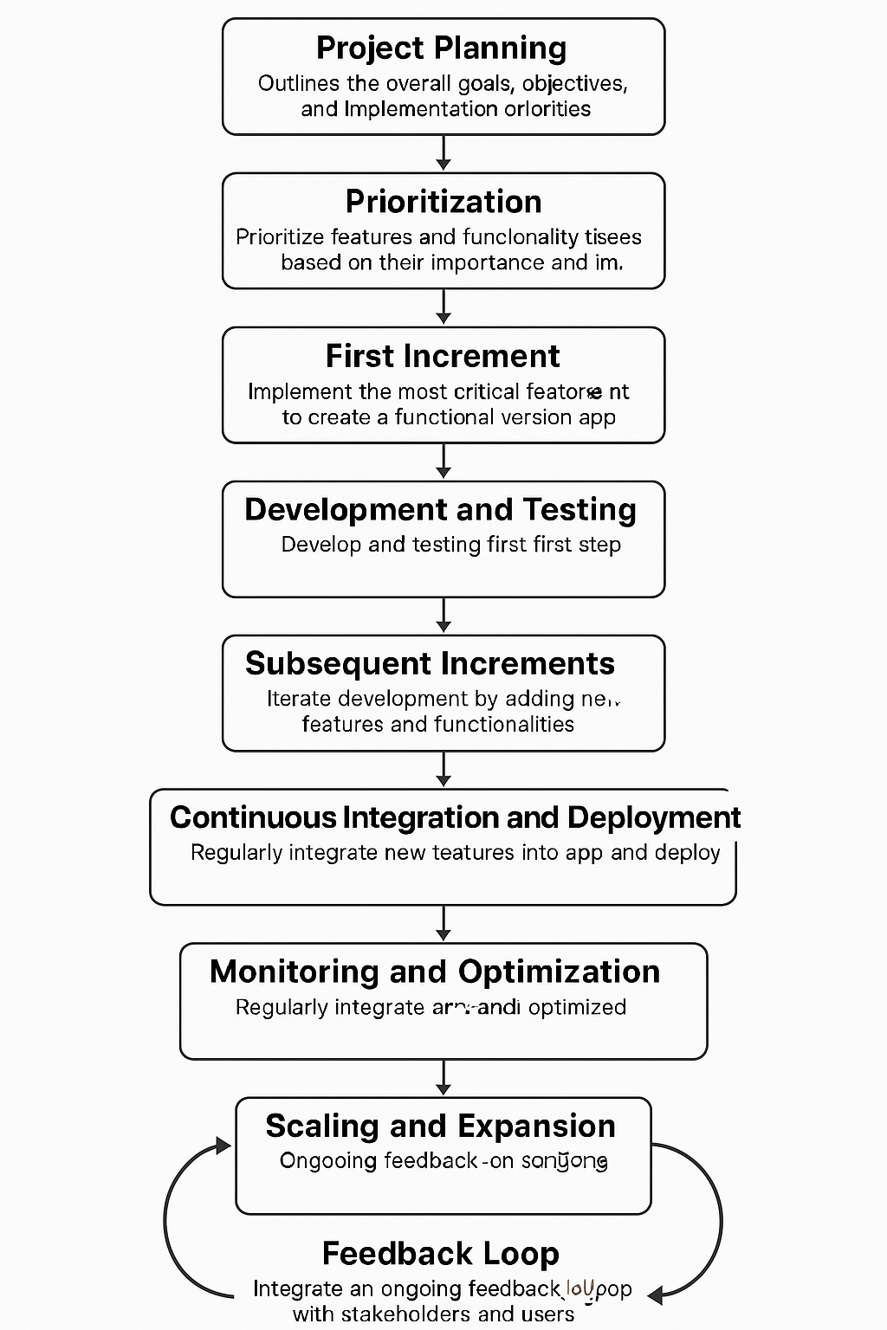

**Figure 3.** Incremental and iterative app development lifecycle

* + 1. AUMOR-AR Development Platform

The open-source Flutter framework, created by Google, was used for developing the application. Flutter is chosen for development of UAMOR-AR because of its simplicity and ability to be customized and scaled which makes suitable for quick development. Additionally, it can generate natively compiled applications for different target platforms such as desktop, web, and mobile from a single codebase which can run on both iOS and Android. Its reactive structure allows developers to view changes instantly without losing state by turning on hot reload capabilities. The Flutter architecture is illustrated in Figure 4. Flutter applications are written in the object-oriented programming language Dart [10] which incorporates vast library of software packages makign simple for developers to improve the features of their apps. Dart runs on C/C++ virtual machines. Flutter app developers utilize Canvas and Events to render widgets on the device screen and access services like geolocation, camera, audio, etc. Additionally, the application employs Ahead of Time compilation as opposed to JavaScript's Just in Time compilation.

Like all native applications, Flutter apps are bundled to the underlying operating system. The entry point is a platform-specific embedder, which also manages the message event loop and interfaces with the operating system to provide access to services like input, accessibility, and rendering surfaces. Currently, Java and C++ for Android, Objective-C/Objective-C++ for iOS and macOS, and C++ for Windows and Linux are the languages used to implement the embedder. With the help of the embedder, Flutter code can be used as a module or as the main body of an application that already exists. Although Flutter comes with several embedders for popular target platforms, there are other options as well. The core components needed to power all Flutter applications are provided by the Flutter engine, which is primarily written in C++. The engine is the foundation for Flutter's main API implementation and is tasked with rasterizing composite scenes whenever a new frame needs to be painted. This includes a Dart runtime and compilation toolchain, text layout, file and network I/O, accessibility capabilities, plugin architecture, graphics functionality (using Impeller on iOS and shortly on Android, and Skia on other platforms), and more.

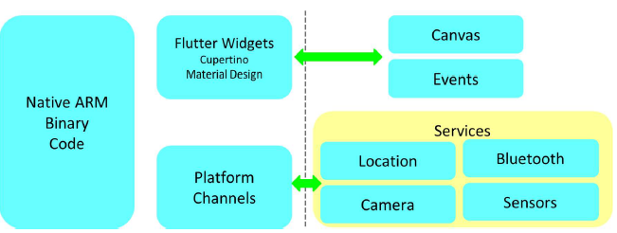

**Figure 4.** Architecture of Flutter Mobile Application Framework.

* + 1. User Interface Design and Navigation Flow

The user interface flow of the AUMOR-AR mobile application is shown in Figure 5. The sequence begins with the app icon on the device’s home screen (Fig. 5(a)), providing quick access to the system. The panels in Fig. 5(b) and Fig. 5(c) show the login screen, where users are required to input their email and password credentials, respectively. The log-in interface features a clean and minimalistic design, with a password visibility toggle, “forgot password” option, and a sign-up prompt for new users. Once authenticated, users are directed to the main feature menu (fourth panel). The menu contains four core functionalities.

* GPS Guide – for navigation and location-based information access on the campus.
* QR Scanner – to retrieve contextual information and resources by scanning QR codes placed across the university facilities.
* Start Quiz: An interactive feature designed to reinforce orientation knowledge through gamified learning.
* Tutorial: Offering guidance and instructions to new users, enhancing ease of use and adoption.

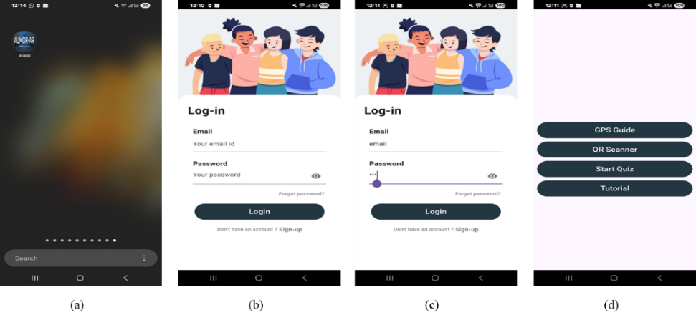Together, these interfaces demonstrate the application’s student-centered design, emphasizing simplicity, accessibility, and the integration of location-based and interactive tools to ensure effective student orientation.

**Figure 5.** User interface flow of the AUMOR-AR application

* + 1. GPS Integration for Location-Based Services

The app uses GPS-based navigation to deliver information when a student approaches a relevant place on campus. As they approach a building, service counter, or outdoor venue, the app activates an AR overlay that anchors to the scene and offers context-specific resources—short web links, quick videos, campus maps, downloadable PDFs, and, where appropriate, simple booking actions (e.g., study rooms or event check-ins). Pairing GPS with AR means that students see what matters for the spot they are standing in, reducing search time and helping first-time visitors move confidently between locations and find their way. To build this experience, we mapped key campus points of interest and recorded their precise coordinates using a campus-based map (via Google Maps). Each location was added to a lightweight JSON catalog that stored its name, latitude/longitude, geofence radius, and set of AR assets to show on arrival, as shown in Figure 6(a). On the app’s map view, this appears as a circle around each location (the geofence) and red markers for individual points—twenty-five in our pilot—so students can see what is nearby at a glance while content updates remain centrally managed.

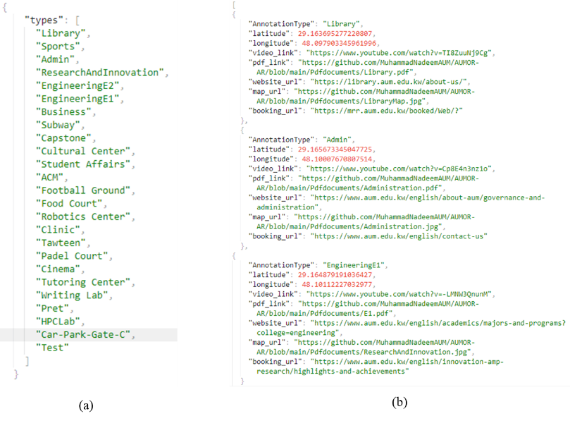

Figure 6. JSON data structure used for annotating campus locations and resources

When a student enters a geofence, the app displays the location name; tapping it opens an AR panel with the available options to select. A student nearing the Administration Building would see a prompt, and upon clicking, assets are streamed from the web to keep the app small, with essential items cached for spotty connectivity. The details of the metadata for the selected annotations, including coordinates, video links, websites, booking links, and related documents, are shown in Figure 6(b). This GPS-plus-AR approach turns the campus into an interactive guide, providing students with timely and trustworthy information as they navigate their orientation.

Figure 7 illustrates the location-based information system of the AUMOR-AR application, designed to support students during university orientation. In the first panel shown in Figure 7(a), the system overlays a radar-style marker on the real-world environment to identify nearby locations, such as laboratories, classrooms, study zones, cafés, and library rooms. Floating labels provide contextual information, including the name of the facility and its distance from the user, thereby enabling intuitive and location-aware navigations. In the second panel shown in Figure 7(b), multiple markers are displayed simultaneously, allowing users to view several facilities within the range, such as business buildings, computer labs, tutoring centers, and capstone project rooms. This functionality provides a comprehensive situational overview, reducing the cognitive load required for navigation on large or unfamiliar campuses. The third panel in Figure 7(c) shows the interactive information panel that is triggered when a user selects a location. This panel provides access to rich multimedia resources, including videos, documents, website links, room maps, and booking options. Such features extend the utility of AR beyond navigation, transforming it into an integrated learning and resource platform for orientation and daily campus use.

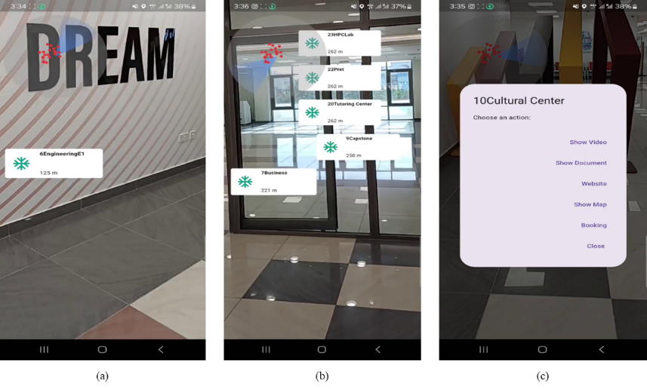

Figure 7. Augmented Reality navigation and resource interface of the AUMOR-AR application

* + 1. QR Code Implementation for Information Retrieval

We paired AR with QR codes that are placed at key locations or on the equipment. Each code encoded a resource name in plain text that the app reads with the camera and resolves against a lightweight JSON catalog mapping that text to an up-to-date content bundle. On scan, the app presents these options as an AR overlay (and accessible list view); tapping opens the selected asset online, keeping the app small while allowing centralized updates without reprinting codes. This scan-to-experience flow delivers just-in-time information on where students stand reducing friction for new users.

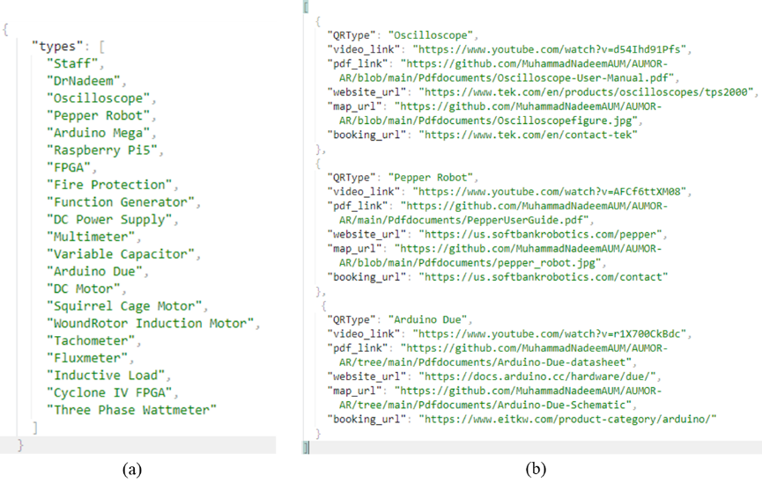

Figure 8. JSON data structure used for annotating laboratory resources embedded with QR code.

Figure 9 demonstrates the application of a QR code enabled information retrieval system designed to facilitate immediate access to technical documentation for the Arduino Due board. As shown on the left in Figure 9(a), the packaging integrates a QR code, establishing a direct link between the physical hardware and relevant digital resources. Upon scanning the QR code, illustrated in the middle panel, the system recognizes the device as “Arduino Due” and presents users with a structured set of options, including video tutorials, datasheets, official website access, schematic drawings, and contact details as shown in Figure 9(b). This functionality exemplifies how QR technology can support efficient knowledge acquisition by minimizing the cognitive and temporal effort required to locate appropriate resources. The panel shown in Figure 9(c) illustrates the redirection to the official Arduino documentation portal, where authoritative materials, such as pinout diagrams, datasheets, circuit schematics, and prototyping files, are provided. Collectively, the workflow highlights the pedagogical and practical value of embedding QR codes into engineering education contexts, as it effectively bridges physical components with digital learning environments, promotes self-directed inquiry, and ensures learners’ engagement with current and reliable technical content.

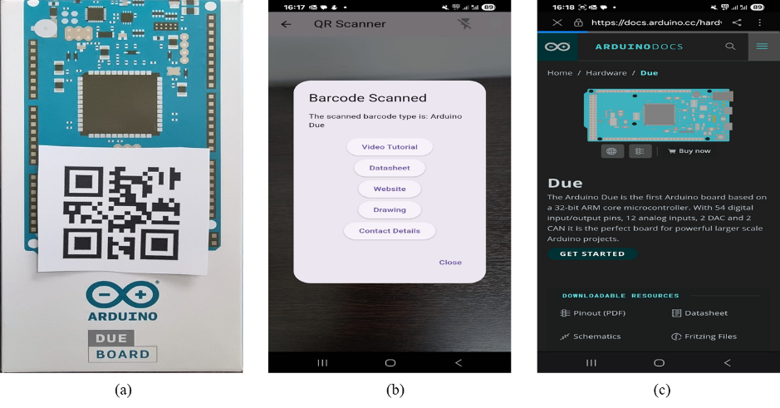

**Figure 9.** Workflow demonstrating QR code–based access to technical resources for the Arduino Due board.

1. **Results**

In this section, we present the evaluation results of AUMOR-AR application. The data collected were analyzed using R software (version 4.0.3). The internal consistency of the survey was very good, with a Cronbach’s alpha of 0.927688. Broken down by subscale, the internal reliability was *α* = .837 (good) for perceived usefulness, *α* = .734 (acceptable) for Perceived Ease of Use, *α* = .822 (good) for ATU, *α* = .828 (good) for BIU, and *α* = .521 (bad) for AU. The low value for AU is expected because the options provided for these questions are distinct features, not parallel items tapping one latent construct. The total number of participants was 128, comprising 39.84% males and 60.16% females, with their current academic levels reported in Table ***2*** below. Most participants were junior (36.72%) or sophomore (31.25 %) students.

**Table 2.** Participant demographics

|  |  |  |  |  |  |  |  |  |
| --- | --- | --- | --- | --- | --- | --- | --- | --- |
| Characteristics | Attributes | | | | | | | Total |
| Participant Gender | Male (51) | | | | Female | | | 128 |
| 39.84% (51) | | | | 60.16% (77) | | | 100% |
| Participant Age (Years) | Freshmen | Sophomore | Junior | Senior | | Faculty | Staff | 128 |
| 12.50% (16) | 31.25% (40) | 63.72% (47) | 15.63% (20) | | 3.13% (4) | 0.78% (1) | 100% |

Approximately one-third of the participants (32.81%, N=42) reported using mobile applications for educational purposes often, and over a third (35%+) said they sometimes did so, meaning that roughly seven in ten engaged in educational use at least intermittently. Only a small minority reported minimal engagement, with 4.69% using them rarely and 1.56% never using them. Taken together, these figures suggest strong readiness for app-based learning tools and imply that modest onboarding and targeted use cases could convert occasional users into more frequent users. Regarding familiarity with AR, most respondents (57.03%, N=73) had not used an AR app before, while 40.63% (N=52) reported prior AR use, and 2.34% (N=3) did not answer. This means that the proposed AR app is new to many students, which helps explain the sizable neutral responses in ease-of-use/usefulness items; many are first-time users still forming opinions. Practically, this points to the value of lightweight onboarding, clear terminology, and performance polish to build early confidence in the user.

The breakdown of the perceived usefulness (PU) of the application is shown in Figure 10. Most of the students found the AUMOR-AR was useful for understanding the university campus layout (60.16%), finding useful information about campus facilities (75%), and overall orientation experience (57.82%). For most participants (74.22%), using the AR app saved time in finding important campus locations, and it helped with confident campus navigation (57.03%).

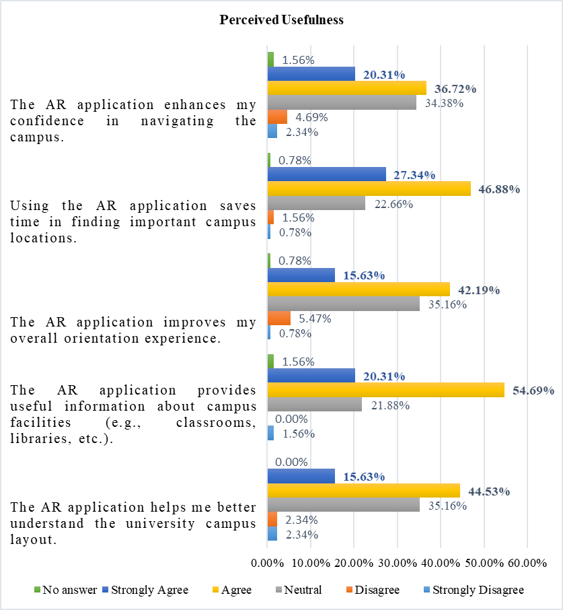

**Figure 10.** Breakdown of perceived usefulness of the AR application.

Figure 11shows abreakdown of the perceived ease of use (PEOU) and most of the survey participants found information about different campus locations easily using the application (71.88% of the participants). They also found the AUMOR-AR app simple to learn and use (70.32%) and did not require additional instructions to understand how to use the application (49.22%). The AR app was quick to respond according to 54.68% of the survey participants, with a user-friendly layout and design (66.41%), and it was not difficult to use (52.35%).

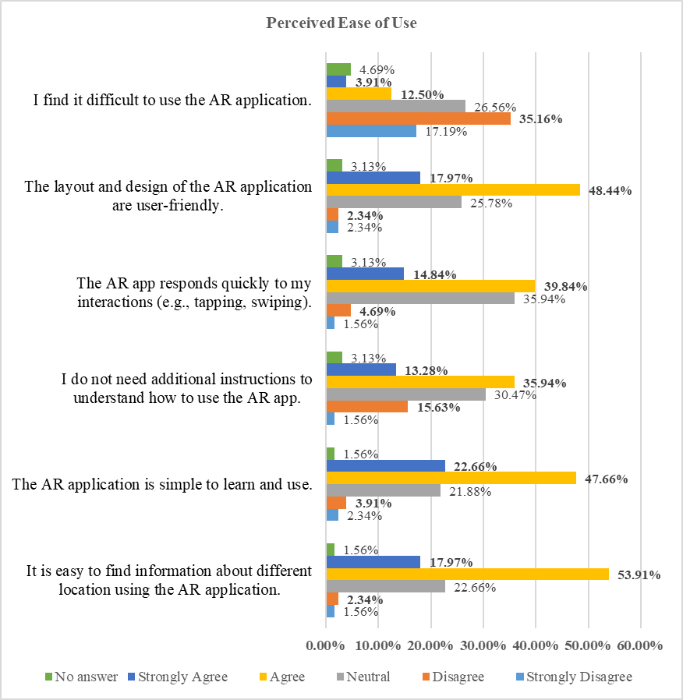

**Figure 11.** Breakdown of the perceived ease of use of AR application.

The ATU results were broadly positive Figure *12*. Students most strongly endorsed the concept, with 75.79% (47.66% agree, 28.13% Strongly Agree) believing that using the AUMOR-AR app for orientation was a good idea, with only 2.34% disagreeing and 18.75% neutral. They also found it engaging, as 71.10% (SA=46.88%, A= 24.22%) said that the app was a fun way to explore the campus, while only 8.59% disagreed and 17.19% were neutral. Personal experience was solid but mixed with 58.60% (SA=40.63%, A=17.97%) feeling confident when navigating the app, while 30.47% were neutral and only 7.04% disagreed. Similarly, 53.91% (SA=37.50%, A=16.41%) enjoyed using it during orientation, with a relatively high 35.94% neutral and 6.25% negative responses. Non-responses were small (3% for each item). In short, students buy into the idea and fun of AR, but a sizeable neutral block on confidence and enjoyment suggests room for improvement to convert the undecided into enthusiastic users.

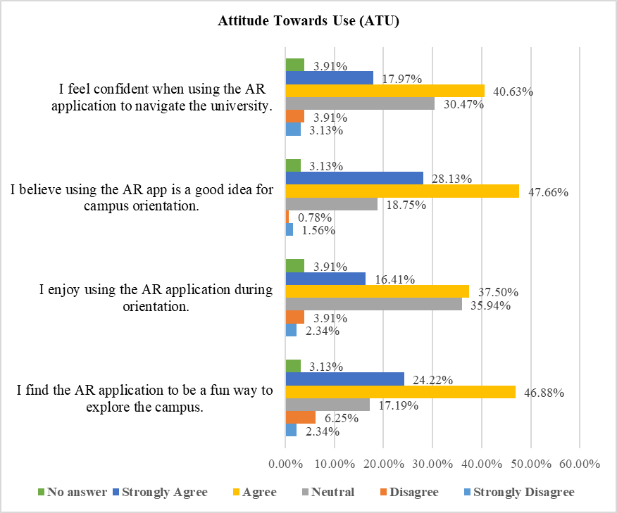

**Figure 12.** Breakdown of attitude towards the use of the AR application.

The Behavioral Intention to Use (BIU) results shown in Figure 13are strong overall as 75.0% would recommend the AR app to other students (42.19% Agree, 32.81% Strongly Agree), with only 7.03% negative and 14.84% neutral. Preference over traditional orientation methods was positive but more mixed with 53.9% favoring the AR approach (33.59% agree, 20.31% Strongly Agree), while 29.69% are neutral and 11.72% disagree suggesting many are open to AR but still comparing it with familiar formats. The intent to continue using the app during university was similarly moderate with 52.35% positive (35.94% agree, 16.41% Strongly Agree), 32.81% neutral, and 10.16% negative.

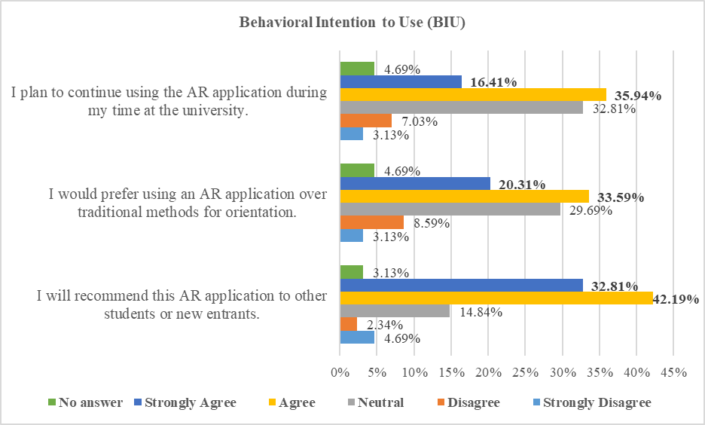

**Figure 13.** Breakdown of the behavioral intention to use AR application.

The breakdown of the usage of the different features of the AUMOR-AR application is presented in Figure 14. We observed that the survey participants used the app mainly for campus navigation (51.56%) and for finding information about laboratory equipment (39.06%). Approximately one-third of the participants used the AR app to locate specific buildings or departments (29.69%), gather information on student services (28.91%), and access event schedules (27.34%). Some participants were also interested in virtual campus tours (18.75% of respondents).

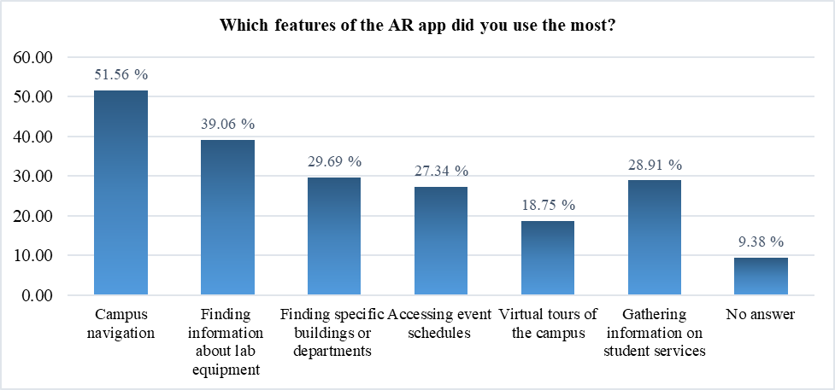

**Figure 14.** Breakdown of the usage of the different features of the AR application.

Figure 15shows the frequency of AR application usage during the orientation. We can observe that 34.38% of the survey participants used the AR application a few times during their orientation, 17.19% used the AR app regularly throughout the orientation, while 10.94% used it only once.

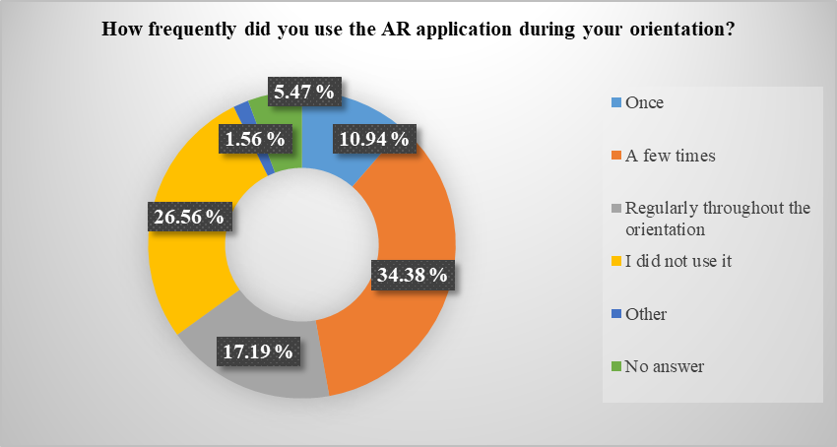

**Figure 15.** Frequency of AR application usage during orientation.

Figure 16shows the intended use of the AR application after orientation. Most of the survey participants were likely or very likely to continue using the AR application after the orientation (57.03% of the total).

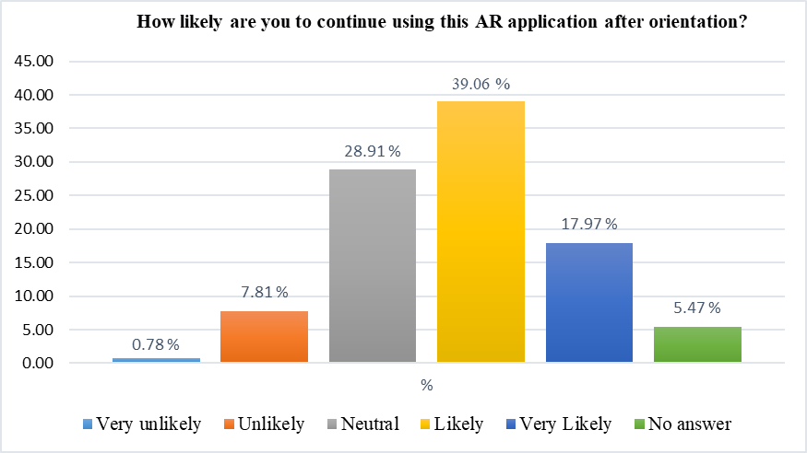

**Figure 16.** Intended usage of the AR application after the orientation

We performed an inductive thematic analysis to the open-ended item “What kind of information would you like to see on the application?” The responses were multi-coded, so totals can exceed 100% and outcomes are as follows.

* Real-time status / availability
* Events & schedules (with reminders)
* Academic info and student services
* Navigation and wayfinding
* Booking of utilities
* Onboarding/help & usability

We also performed an inductive thematic analysis to the second open-ended item “What will you suggest improving this application?” The responses were multi-coded, so totals can exceed 100% and the outcomes were as follows:

* iOS availability / distribution
* Performance, reliability & accuracy
* UI/UX simplification & modernization
* Live status features
* Content expansions (services & hours)

1. **Discussion**
   1. *Interpretation of Evaluation Results*

The evaluation results of AUMOR-AR confirmed the potential of augmented reality combined with GPS and QR code technologies to improve the orientation experience of new students. The highest ratings were for perceived usefulness in terms of time-saving and facility information (~74–75%), reflecting the app’s success in addressing students’ immediate need for quick access to contextual information. This aligns with prior research indicating that mobile applications are particularly valued when they reduce effort and provide convenience in real-world tasks. However, ratings for confidence in navigation (~57%) and improvement in overall orientation experience (~58%) were more moderate, suggesting that the app currently functions more as an information delivery tool than as a complete wayfinding solution for visitors.

The ease of use results were similarly promising, with a majority of participants finding the application simple to learn (approximately 70%), intuitive for accessing campus-related information (approximately 72%), and user-friendly in its layout (approximately 66%). These findings align with the core tenets of the Technology Acceptance Model (TAM), which emphasizes *perceived ease of use* as a critical factor influencing user acceptance and sustained engagement with technology (Davis, 1989). Numerous studies have reaffirmed that ease of use significantly predicts behavioral intention and actual usage, especially in educational technology contexts (Putri et al., 2025; Mercer & La Marca, 2024). Specifically, in AR-based learning environments, students who perceive systems as easier to navigate are more likely to develop positive attitudes and trust in the system (Putri et al., 2025); however, the relatively weaker scores in system responsiveness and the expressed need for onboarding support suggest areas for improvement. These concerns are consistent with findings that underscore the importance of system responsiveness and structured onboarding in AR applications to reduce cognitive load and anxiety (Bello & Abdurrahman, 2025; Idkhan et al., 2025). Given that many students may be unfamiliar with AR technologies, the integration of short guided tutorials and improved system responsiveness could substantially enhance user confidence and overall adoption of AR. Prior research indicates that structured support materials and smooth interface feedback loops act as critical enablers in bridging initial resistance and improving the perceived ease of use (Buchem et al., 2025; Gong et al., 2025).

The results regarding attitude towards use show strong endorsement of AUMOR-AR as a valuable and engaging tool for university orientation. Nearly three-quarters of respondents (≈76%) agreed or strongly agreed that using the AR app was a good idea for orientation, and over 70% found it a fun way to explore campus. These findings highlight that students view AR as functional and enjoyable, supporting the premise that perceived enjoyment can reinforce acceptance, as noted in the extended versions of the Technology Acceptance Model 3 (TAM3). However, indicators of confidence and personal enjoyment during orientation were somewhat lower (≈54–59%), with a sizable proportion of neutral responses (≈30–36%). This suggests that while the concept of AR is broadly attractive, some students remain cautious or undecided about its reliability and personal value for practical use in the classroom. Such hesitation is often linked to first-time exposure to AR technologies, as many participants (57%) had never used AR before. Practical strategies to improve confidence could include micro-onboarding (short tutorials, tooltips, or guided “first use” experiences), performance optimization to reduce lag, and improved indoor navigation accuracy. These measures can convert neutral attitudes into more enthusiastic adoption, maximizing the impact of AUMOR-AR.

The outcomes of behavioral intention were similarly promising. Most students (75%) reported a willingness to recommend the AR app to their peers, demonstrating a strong word-of-mouth potential. Over half expressed a preference for AR-based orientation over traditional methods (~54%) and indicated plans to continue using the app during their studies (~52%). These results suggest that AUMOR-AR has a clear pathway for sustained adoption, provided that its reliability and relevance continue to improve. Nonetheless, the relatively large neutral segments (≈30%) for both preference and continued use point to the need for deeper integration of the app into students’ daily academic lives. Features such as real-time event reminders, schedule-linked routing to classrooms, live updates on facilities, and academic service integration (grades, office hours) could embed the app into routine student practice. Aligning AR content with students’ immediate academic and administrative needs may transform the app from a one-time orientation aid to a long-term companion throughout their university journey. In line with TAM, the BIU findings underscore that positive attitudes and perceived usefulness drive the intention to use. By capitalizing on high recommendation rates and strategically addressing areas of hesitation, universities can ensure that AR orientation apps such as AUMOR-AR become an integral part of the student experience, rather than a novelty used only at the start of the academic year.

The analysis of student feedback highlighted six major domains of desired mobile application features for enhancing the campus experience. Real-time status and availability information was frequently emphasized (~25–30%), with students requesting live updates on parking occupancy, building or café crowding, event changes, and utilities such as power or air conditioning status. These features reflect the increasing demand for context-aware smart campus systems that improve mobility and decision-making in real time (Alsaeedi & Al-Sarem, 2021).

*“Available parking; if the building is crowded or not”; “real time bus schedules and cafeteria menus”; “real time updates about campus events.”*

Events and schedules were also a high priority (~20–25%), with students requesting centralized access to event dates, semester-specific schedules, and integrated reminder functions, aligning with prior findings that calendar-linked notifications significantly improve student engagement (Aljohani, 2019).

*“Events (date, when?)”; “event schedules for all majors”; “events table”; “reminders”*

The largest category (~30–35%) was academic information and student services, including grades, GPA tracking, assessment feedback, project updates, and faculty office hours. This resonates with previous research indicating that academic transparency and immediate access to assessment data strongly influence students’ satisfaction with learning technologies (Davis et al., 2022).

*“Maybe if it could show the students’ grade in each assessment”; “What GPA I have”; “office hours of faculty… course projects”*

Navigation and wayfinding was another prominent need (~25–30%), where students envisioned location-aware routing linked directly to their class schedules, echoing evidence that location-based services improve campus accessibility and efficiency (Shen et al., 2018).

*“Campus navigation”; “when I click on my class it shows me the way”; “places of every building”*

Meanwhile, booking and utilities (~5–10%) focused on study room reservations and workshop/lab bookings, functions that are increasingly integrated into smart campus platforms (Caviglione et al., 2020).

*“Book spots/rooms for studying”; “booking workshop like robotics”*

Finally, onboarding, help, and usability (~10–15%) were cited, including requests for clearer information, full campus guides, and FAQ sections, which were particularly valuable for first-year students adapting to a new academic environment (Henderson et al., 2017).

*“More clear information”; “A full guide… with feedback”; “a FAQ section for new students”*

Collectively, these findings indicate that students prioritize functionality that reduces uncertainty, supports academic progress, and personalizes campus engagement, reinforcing the growing role of mobile and smart technologies in shaping higher-education experiences.

Student feedback on desired improvements to the campus mobile application emphasized six key domains of functionality. iOS availability and distribution emerged as the most frequently mentioned (~30–40%), with students requesting that the app be made accessible via the Apple App Store to support iPhone users. This aligns with broader evidence showing that cross-platform compatibility significantly increases adoption and inclusivity in mobile applications for higher education (Mtebe & Raisamo, 2014).

*“Upload it in the Apple…”, “make it for iOS”, “allow iPhone users to download it”*

Performance, reliability, and accuracy (~25–30%) were also highlighted, with students demanding faster load times, bug fixes, and more precise locations and AR features. Prior studies have similarly shown that system responsiveness and reliability are critical determinants of user satisfaction and continued use of educational apps (Sarrab et al., 2015).

*Faster response… quicker updates”, “more precise locations”, “fix bugs”*

Another prominent theme was UI/UX simplification and modernization (~20–25%), where students requested clearer layouts, organized lists, and more interactive designs. Research on learning technologies confirms that well-structured and aesthetically modernized interfaces reduce cognitive load and increase user engagement (Nouri, 2018).

*“Make the layout clearer”, “organize everything in lists”, “update the app design”*

Students also requested notifications and reminders (~10–15%), including alerts for schedules, assignments, and events, reflecting earlier findings that push notifications and reminders enhance time management and academic performance (Aljohani, 2019).

*“Alerts that remind you about schedule”, “assignment reminders”*

Finally, content expansions (~15–20%) were noted, with calls for more comprehensive coverage of office locations, hours, semester dates, and class times. Such expansions alignn with research showing that information-rich applications increase perceived usefulness and institutional trust (Henderson et al., 2017).

*“office hours and office place”, “updated semester schedule”*

Collectively, these insights suggest that students prioritize inclusivity, reliability, modern design, and real-time support as essential for the effectiveness of smart campus mobile applications.

* 1. *Strengths and Weaknesses of AUMOR-AR*

AUMOR-AR’s main strengths lie in the integration of GPS and QR code scanning with AR overlays, which provide students with contextualized, real-time information. This design was appreciated for its ability to reduce the time spent searching for facilities and resources, which aligns well with the goals of orientation programs. Its incremental development model also allows for iterative improvements and scalability.

However, some weaknesses were also evident. Senior students who were already familiar with the campus found limited added value in basic navigation and facility information. Moreover, performance limitations, such as lag in AR responsiveness and occasional imprecision in location detection, reduce user confidence. Accessibility gaps were also highlighted, especially the lack of iOS compatibility, which was one of the most common suggestions for improvement by the participants. These weaknesses echo the findings of previous AR campus systems, which frequently encountered barriers related to technical stability, inclusivity, and scalability.

* 1. *Comparison with Previous Studies*

Compared with earlier AR-based orientation initiatives, AUMOR-AR offers several advantages. Early systems, such as those at Columbia University and Fu-Jen Catholic University, focused on head-mounted displays or AR visualization of campus landmarks; however, they often required specialized hardware and offered limited scalability. More recent efforts at Chung Hua University and the University of Quindío integrated multimedia and 3D directional boards; however, they lacked GPS precision and QR code versatility. In contrast, AUMOR-AR’s hybrid approach, which leverages widely available smartphone hardware with both GPS-based geofencing and QR-triggered AR overlays, achieves broader accessibility and reduces the reliance on costly infrastructure.

Furthermore, AUMOR-AR’s evaluation of over 120 participants adds to the literature by providing a large-scale, empirical dataset. While studies at universities such as Bowling Green State or Haaga-Helia UAS focused on niche features (cultural exploration or missed orientation catch-up), AUMOR-AR demonstrates the feasibility of embedding AR into mainstream orientation practices in higher education. Its integration of TAM as an evaluative framework also provides a theoretical contribution, bridging technology adoption theory with situated learning perspectives in the university orientation context.

* 1. *Implications for University Orientation Practices*

The implications of this study for practice are thus significant. First, AUMOR demonstrates that mobile AR can complement or partially substitute traditional orientation programss, which are resource-intensive and costly. By embedding real-time information at physical locations through QR codes and GPS triggers, the app promotes situated learning, enabling students to learn by doing in authentic campus contexts. Second, the open-ended feedback from students underscores the demand for richer real-time functionality, including live updates on parking, event schedules, and crowding, as well as integration with academic services. Incorporating these features would extend the utility of AR beyond orientation into everyday student life and foster a long-term engagement. Finally, the results reinforce that technology adoption hinges not only on novelty but also on reliability, inclusivity, and relevance. Addressing performance stability, expanding platform availability, and layering personalized academic content are essential steps for maximizing the impact. In the broader landscape of AR orientation research, AUMOR represents a meaningful step forward by combining affordability, accessibility, and empirical validation, thus offering a model for institutions seeking to modernize their orientation practices.

* 1. *Alignment with Sustainable Development Goals*

Beyond its immediate contributions to orientation, AUMOR aligns with the United Nations Sustainable Development Goals (SDGs). By enhancing access to information and improving the quality of student transition experiences, the app supports SDG 4 (Quality Education), which emphasizes inclusive and equitable access to lifelong learning. The system also reflects SDG 9 (Industry, Innovation, and Infrastructure) as it leverages cutting-edge mobile and AR technologies to build a scalable digital infrastructure for higher education. Moreover, by reducing reliance on resource-intensive traditional orientation events, AUMOR-AR indirectly contributes to SDG 12 (Responsible Consumption and Production) by lowering costs and minimizing environmental impact. Thus, the project not only addresses the local challenge of student orientation but also contributes to global priorities for sustainable and technology-enabled education.

1. **Conclusion**

This study presents the design, implementation, and evaluation of the AUMOR-AR application, a personalized mobile tool developed to support student orientation and navigation within a university campus. By integrating augmented reality, GPS, and QR code technologies, the application demonstrated its potential to address a persistent challenge faced by students: feeling disoriented, overwhelmed, and time-pressed in large and complex academic environments. The evaluation results indicated that students found the system useful for saving time and accessing facility information, and the clean design and simple interface contributed to their perceptions of ease of use. Furthermore, the incorporation of interactive features, such as floating labels, multimedia resources, and quizzes, highlights the versatility of AR as a navigation aid and a tool for engagement and learning. Research on GPS and QR code-based AR applications for university orientation advances educational technology. Researchers can explore innovative approaches to enhance student orientation experiences and contribute to the literature on immersive learning environments. Student services offices can leverage these findings by integrating AR applications into orientation activities to provide interactive experiences that promotee engagement. AR applications create engaging learning experiences that appeal to digitally savvy students and enhance their learning. Despite its promise, the study also revealed areas for improvement, including the need for performance optimization, cross-platform availability, and enhanced model personalization. These findings underscore that technology adoption is shaped not only by novelty but also by reliability, inclusivity, and relevance to students’ daily needs. Compared with previous AR-based orientation systems, AUMOR advances the field by combining affordability, scalability, and empirical validation in a real-world context. Future work should focus on refining the application for broader deployment and expanding its features to include live event updates, academic service integration, and accessibility options to support diverse student populations. Thus, AUMOR can evolve into a comprehensive digital campus companion that contributes to improved student experience, time management, and well-being of students.

**Supplementary Materials:** The following supporting information can be downloaded at: https://www.mdpi.com/article/doi/s1, Figure S1: title; Table S1: title; Video S1: title.

**Author Contributions:** For research articles with several authors, a short paragraph specifying their individual contributions must be provided. The following statements should be used “Conceptualization, X.X. and Y.Y.; methodology, X.X.; software, X.X.; validation, X.X., Y.Y. and Z.Z.; formal analysis, X.X.; investigation, X.X.; resources, X.X.; data curation, X.X.; writing—original draft preparation, X.X.; writing—review and editing, X.X.; visualization, X.X.; supervision, X.X.; project administration, X.X.; funding acquisition, Y.Y. All authors have read and agreed to the published version of the manuscript.” Please turn to the [CRediT taxonomy](https://img.mdpi.org/data/contributor-role-instruction.pdf) for the term explanation. Authorship must be limited to those who have contributed substantially to the work reported.

**Funding:** Please add: “This research received no external funding”

**Data Availability Statement:** We encourage all authors of articles published in MDPI journals to share their research data.

**Conflicts of Interest:** The authors declare no conflicts of interest.”

Abbreviations

The following abbreviations are used in this manuscript:

|  |  |
| --- | --- |
| MDPI | Multidisciplinary Digital Publishing Institute |
| DOAJ | Directory of open access journals |
| TLA | Three letter acronym |
| LD | Linear dichroism |

Appendix A

*Table 1. Questionnaire Used in User Testing*

|  |  |  |  |  |  |  |  |  |  |  |
| --- | --- | --- | --- | --- | --- | --- | --- | --- | --- | --- |
| **Q.#** | **Resp.** |  | | | | | | |  | |
| **Female** | **Male** | **Freshmen** | **Sophomore** | **Junior** | **Senior** | **Faculty** | **TCG6** | **TCG7** |
| **Q1** | SA+A | 15(83.3%) | 45(54.2%) | 14(58.34%) | 19(65.52%) | 8(61.54%) | 9(52.94% | 11(61.11%) | 50(79.4%) | 31(70.5%) |
| D+SD | 2(11.10%) | 9(10.8%) | 5(20.83%) | 8(27.59%) | 4(30.77%) | 6(35.29%) | 5(27.68%) | 6(9.5%) | 2(4.5%) |
| N | 1(5.6%) | 29(34.9%) | 5(20.83%) | 2(6.89%) | 1(7.69%) | 2(11.77%) | 2(11.11%) | 7(11.1%) | 11(25.0%) |
| **Q2** | SA+A | 16(88.9%) | 59(71.1%) | 14(58.33%) | 24(82.76%) | 9(69.23%) | 12(70.59%) | 16(88.89%) | 49(77.8%) | 31(70.5%) |
| D+SD | 1(5.56%) | 6(7.23%) | 5(20.83%) | 5(17.24%) | 3(23.08%) | 5(29.41%) | 1(5.56%) | 2(3.2%) | 0(0.0%) |
| N | 1(5.56%) | 18(21.7%) | 5(20.83%) | 0(0.00%) | 1(7.69%) | 0(0.00%) | 1(5.56%) | 12(19.0%) | 13(29.5%) |
| **Q3** | SA+A | 16(88.9%) | 62(74.7%) | 20(83.33%) | 23(79.31%) | 9(69.23%) | 12(64.70%) | 14(77.78%) | 48(76.2%) | 34(77.3%) |
| D+SD | 1(05.6%) | 12(14.0%) | 0(0.00%) | 3(10.34%) | 3(28.08%) | 2(17.65%) | 2(11.11%) | 4(6.3%) | 4(9.09%) |
| N | 1(05.6%) | 9(10.8%) | 4(16.67%) | 3(10.34%) | 1(7.69%) | 3(17.65%) | 2(11.11%) | 11(17.5%) | 6 (13.6%) |
| **Q4** | SA+A | 9(50.0%) | 9(47.00%) | 15(62.50%) | 10(34.48%) | 4(30.77%) | 10(58.82%) | 9(50.00%) | 33(52.4%) | 20(45.5%) |
| D+SD | 3(16.7%) | 17(20.5%) | 5(20.83%) | 11(37.93%) | 7(53.85%) | 4(23.53%) | 6(33.33%) | 8(12.7%) | 9(20.4%) |
| N | 6(33.3%) | 27(32.5%) | 4(16.67%) | 8(27.59%) | 2(15.38%) | 3(17.65%) | 3(16.67%) | 22(34.9%) | 15(34.1%) |
| **Q5** | SA+A | 11(61.1%) | 57(68.7%) | 18(65.00%) | 21(72.41%) | 10(61.54%) | 10(58.82%) | 11(55.55%) | 48(76.2%) | 35(79.5%) |
| D+SD | 1(05.6%) | 7(8.4%) | 4(16.67%) | 6(20.69%) | 3(23.08%) | 4(23.53%) | 6(33.33%) | 3 (4.8%) | 3 (6.8%) |
| N | 6(33.30%) | 19(22.9%) | 2(8.33%) | 2(6.90%) | 2(15.38%) | 3(17.65%) | 1(5.56%) | 12(19.0%) | 6 (13.6%) |
| **Q6** | SA+A | 10(55.6%) | 50(60.2%) | 15(62.50%) | 17(58.62%) | 7(53.85%) | 11(64.71%) | 10(55.56%) | 50(79.4%) | 31(70.5%) |
| D+SD | 2(11.1%) | 12(14.50%) | 4(16.67%) | 9(31.03%) | 4(30.77%) | 4(23.53%) | 6(33.33%) | 1(1.59%) | 2(4.55%) |
| N | (33.3%) | 21(25.3%) | 5(20.83%) | 3(10.34%) | 2(15.38%) | 2(11.76%) | 2(11.11%) | 12(19.0%) | 11(25.0%) |
| **Q7** | SA+A | 39(47.0%) | 0(0.0%) | 13(54.17%) | 11(37.93%) | 5(38.46%) | 10(58.82%) | 13(72.22%) | 39(61.9%) | 26(59.1%) |
| D+SD | 16(19.3%) | 0(00.0%) | 6(25.00%) | 13(44.83%) | 4(30.77%) | 5(29.41%) | 3(16.67%) | 3(4.76%) | 6(13.6%) |
| N | 3(16.70%) | 28(33.7%) | 5(20.83%) | 5(17.24%) | 4(30.77%) | 2(11.76%) | 2(11.11%) | 21(33.3%) | 12(27.3%) |
| **Q8** | SA+A | 11(61.1%) | 41(49.4%) | 15(62.50%) | 10(34.48%) | 6(46.15%) | 10(58.82%) | 11(61.11%) | 35(55.6%) | 27(61.4%) |
| D+SD | 15(18.1%) | 0(0.0%) | 5(20.83%) | 11(37.93%) | 5(38.46%) | 6(35.29%) | 3(16.67%) | 6(9.52%) | 7(15.9%) |
| N | 3(16.7%) | 27(32.5%) | 4(16.67%) | 8(27.59%) | 2(15.38%) | 1(5.88%) | 4(22.22%) | 22(34.9%) | 10(22.7%) |
| **Q9** | SA+A | 11(61.1%) | 49(59.0%) | 15(62.50%) | 16(55.17%) | 7(53.85%) | 11(64.71%) | 11(61.11%) | 38(60.3%) | 33(75.0%) |
| D+SD | 3(16.7%) | 15(18.1%) | 4(16.67%) | 7(24.14%) | 5(38.46%) | 3(17.65%) | 4(22.22%) | 10(15.9%) | 5(11.4%) |
| N | 4(22.20%) | 19(22.90%) | 5(20.83%) | 6(20.69%) | 1(15.38%) | 3(17.65%) | 3(16.67%) | 15(23.8%) | 6(13.6%) |
| **Q10** | SA+A | 11(61.1%) | 51(61.4%) | 14(58.33%) | 18(62.07%) | 7(53.85%) | 12(70.59%) | 11(61.11%) | 36(57.1%) | 26(59.1%) |
| D+SD | 1(5.56%) | 13(15.7%) | 4(16.67%) | 8(27.59%) | 4(30.77%) | 3(17.65%) | 6(33.33%) | 8(12.7%) | 5(11.4%) |
| N | 6(33.3%) | 19(22.9%) | 6(25.00%) | 3(10.34%) | 2(15.38%) | 2(11.76%) | 1(5.56%) | 19(30.2%) | 13(29.5%) |
| **Q11** | SA+A | 9(50.0%) | 51(61.4%) | 16(66.67%) | 14(48.28%) | 9(69.23%) | 12(70.59%) | 9(50.00%) | 34(54.0%) | 20(45.5%) |
| D+SD | 5(27.8%) | 15(18.1%) | 4(16.67%) | 7(24.14%) | 3(23.08%) | 3(17.65%) | 4(22.22%) | 13(20.6%) | 11(25.0%) |
| N | 4(22.2%) | 17(20.5%) | 4(16.67%) | 8(48.28%) | 1(7.69%) | 2(11.76%) | 5(27.78%) | 16(25.4%) | 13(29.5%) |
| **Q12** | SA+A | 9(50.0%) | 31(37.3%) | 10(41.67%) | 9(31.03%) | 2(15.38%) | 10(58.82%) | 9(50.00%) | 33(52.4%) | 17(38.6%) |
| D+SD | 4(22.2%) | 34(41.0%) | 5(20.83%) | 6(20.69%) | 5(38.46%) | 2(11.76%) | 5(27.78%) | 13(20.6%) | 16(36.4%) |
| N | 5(27.8%) | 18(21.7%) | 9(37.50%) | 14(48.28%) | 6(46.15%) | 5(29.41%) | 4(22.22%) | 17(27.0%) | 11(25.0%) |
| **Q13** | SA+A | 14(77.8%) | 62(74.7%) | 17(70.83%) | 22(75.86%) | 9(69.23%) | 14(82.35%) | 14(77.78%) | 52(82.5%) | 37(84.1%) |
| D+SD | 1(5.56%) | 3(03.6%) | 6(25.00%) | 5(17.24%) | 4(30.77%) | 3(17.65%) | 3(16.67%) | 2(3.2%) | 1(2.3%) |
| N | 3(16.7%) | 18(21.7%) | 1(4.17%) | 2(6.90%) | 0(0.00%) | 0(0.00%) | 1(5.56%) | 9(14.3%) | 6(13.6%) |

**Appendix B. Questionnaire Used in User Testing**

**Appendix C. Sample Screenshots of AUMOR-AR**

**Table A1.** This is a table caption.

|  |  |  |
| --- | --- | --- |
| **Title 1** | **Title 2** | **Title 3** |
| entry 1 | data | data |
| entry 2 | data | data |

Appendix B

All appendix sections must be cited in the main text. In the appendices, Figures, Tables, etc. should be labeled starting with “A”—e.g., Figure A1, Figure A2, etc.

References

1. Author 1, A.B.; Author 2, C.D. Title of the article. *Abbreviated Journal Name* **Year**, *Volume*, page range.
2. Author 1, A.; Author 2, B. Title of the chapter. In *Book Title*, 2nd ed.; Editor 1, A., Editor 2, B., Eds.; Publisher: Publisher Location, Country, 2007; Volume 3, pp. 154–196.
3. Author 1, A.; Author 2, B. *Book Title*, 3rd ed.; Publisher: Publisher Location, Country, 2008; pp. 154–196.
4. Author 1, A.B.; Author 2, C. Title of Unpublished Work. *Abbreviated Journal Name* year, *phrase indicating stage of publication (submitted; accepted; in press)*.
5. Author 1, A.B. (University, City, State, Country); Author 2, C. (Institute, City, State, Country). Personal communication, 2012.
6. Author 1, A.B.; Author 2, C.D.; Author 3, E.F. Title of Presentation. In Proceedings of the Name of the Conference, Location of Conference, Country, Date of Conference (Day Month Year).
7. Author 1, A.B. Title of Thesis. Level of Thesis, Degree-Granting University, Location of University, Date of Completion.
8. Title of Site. Available online: URL (accessed on Day Month Year).

**Disclaimer/Publisher’s Note:** The statements, opinions and data contained in all publications are solely those of the individual author(s) and contributor(s) and not of MDPI and/or the editor(s). MDPI and/or the editor(s) disclaim responsibility for any injury to people or property resulting from any ideas, methods, instructions or products referred to in the content.